**Traditional British Food**

**Objectives:**

To revise and practice vocabulary on the topic of the lesson;

To enrich pupils’ vocabulary on the given topic;

To revise grammar material;

To teach to use the gained knowledge and information in speech;

To develop pupils’ skills in listening, reading, speaking and writing;

To provide interactive work in pairs

To develop pupils’ communicative skills;

To develop pupils’ socio-linguistic skills;

To widen the pupils’ outlook:

To bring up the interest towards the traditions of English-speaking countries.

**Materials:** a laptop, worksheets, a blackboard, posters, cards with dialogues.

**Procedure**

**I. Introduction**

1. **Greetings**

**T:** Good morning, boys and girls, good morning, dear guests. Nice to see you.

**Ps:** Good morning, teacher. Good morning, dear guests.

**T:** How are you today?

**Ps:** We are fine, thank you.

**T:** Today we have an unusual lesson.

1. **Announcement of the topic and aims of the lesson**

**T:** Dear boys and girls, dear guests, welcome to the morning show at our food channel. Look at the screen. I suppose you can guess the topic of our conversation. So, what is it?

**Ps:** I think, we’ll speak about British food.

**T:** Yes, you are right. Our today’s theme is “Traditional British Food”. We’ll speak, read, write and revise some words and grammar rules on the topic “Food”, we’ll watch an interesting video and by the end of our meeting you’ll get to know a lot of interesting things about British meals and some traditional dishes.

Today you’ll be viewers, journalists or participants of different programs. So, smile and have a good time. Welcome to our food channel!

**II. The main part of the lesson**

1. **Phonetic drill**

**T:** Our first program is “Phonetic drill for breakfast”. Listen to me and say after me.

**[˄]** butter, mushroom, curry

**[æ]** cabbage, apple, sandwich, jam

**[ı]** fish, chips, biscuit

**[e]** bread, egg, lemon

**[i:]** tea, meat, beans, meal

**[aı]** rice, ice cream, pie

1. **Warming- up**

**T:** Ok. We have already warmed up our tongues, let’s warm up our brains. And our next program is quiz “What is it?”

1. **Vocabulary practice**
2. **T:**  Look at the screen. I’ll read the description, you’ll say the answer
3. You need me to make a sandwich or toast.
4. I’m yellow and people like me on their pizza.
5. I am small round red fruit. I grow on trees.
6. It is white. It is oval. It is good to eat for breakfast. It comes from a hen.
7. We are a very small round green vegetable.
8. Cats like to drink it.
9. Rabbits just love this vegetable.
10. This is a long yellow fruit. Monkeys love this fruit.
11. It can be from orange, apple, banana, cherry. We drink it.
12. It is yellow and sweet. Bears like it.
13. I am a round fruit. I am usually green, yellow or red.
14. It is fruit and colour. It is round.

2) **T:** Thank you. You are so good. Our next program is “Housekeeping encyclopaedia”. Do you know that different products must be kept in different places in the fridge, e.g. fruit and vegetables are usually kept in the bottom of the fridge. And it’s a very bad idea to mix them on one shelf. So, I have got a neighbour Steve. He’s a good guy, but he’s very bad in housekeeping. I have some pictures of his fridge. Look and say, what’s the odd?

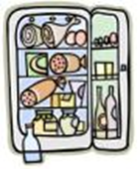

1.  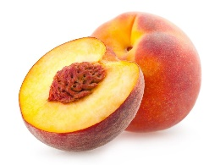  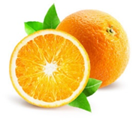
2.    
3.  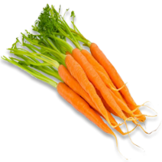 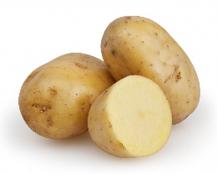 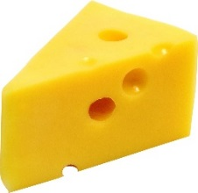
4.    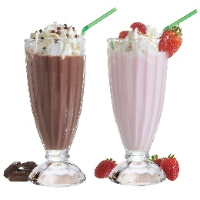

5. 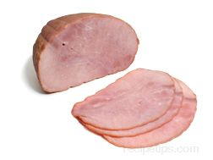 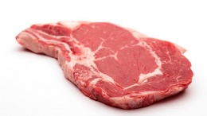 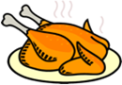 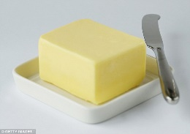

**4. Development of grammar skills.**

**T:** Thank you. It’s time for our next program. Welcome to “Tasty grammar”. In this program, we’ll revise a grammar rule. Look at the screen. Here you will see some pictures. I’ll say the word and you should clap your hands two times if the noun is countable or stamp your feet if the noun is uncountable.

 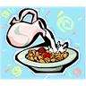 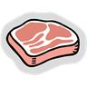  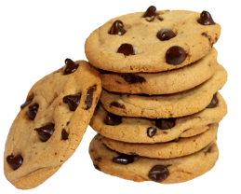 

..…………

 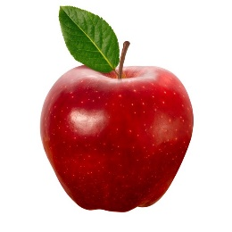 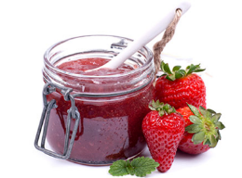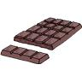 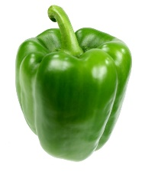

**5. Checking homework.**

**T:** OK. At home you had to do two exercises. Open your copy-books and we’ll check how you understood the rule about using the words *some* and *any*. Let’s read the sentences.

1. There is …… milk in your mug.

2. There isn’t …… ham for breakfast.

3. There are …… apples in the basket.

4. There isn’t …… ice cream in the fridge

5. There aren’t……oranges left.

6. There’s………cheese on the table.

**T:** In the second task you had to complete the questions with *How much* or *How many*.

1. How………sandwiches would you like?

2. How………jam do you need?

3. How………tea do you drink for dinner?

4. How………eggs are there on the table?

5. How………sweets have you got?

6. How………juice would you like?

**T:** Well done. I’m pleased with you. You are so active and energetic today. And let’s work together in the next program “Meals around the world”. On your desks you have a text “British meals”. We’ll read it loudly and you should use the words instead of pictures.

1. **Reading Comprehension**

**British meals**

The English take four meals a day: breakfast, lunch, tea and dinner or supper. In England breakfast time is between seven and nine. For breakfast lots of British people have a bowl of _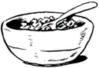_ or ____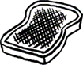with __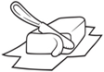__ or __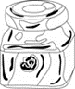_ and a ___. But the traditional English breakfast consists of fried ______, beans, ___, bacon, fried ___ and __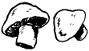___.

Lunch time is between twelve and two pm. For lunch they have a __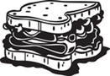__, a packet of _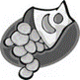_, a piece of __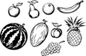__ and something to drink as _____, ____, ____ or __.

Most British people have dinner between 6 and 8 pm. A traditional British dinner (or supper) meal usually consisted of __ or __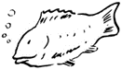_ and two different _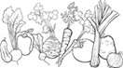. One of the vegetables is usually_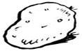_.Today,

a lot of British people like Italian, Chinese and Indian food. Popular dinner dishes are ___ , __ or curry. They also like ___ and _. People often get takeaway meals — they buy the food at the restaurant and

then bring it home to eat.

1. **Post-reading activities**

**T:** Let’s check how you understood the text. Please agree or disagree with the statements. Who wants to be the first?

* The English have four meals a day.
* In England breakfast time is between seven and nine.
* The traditional English breakfast consists of a glass of milk and some biscuits.
* Curry is a popular dish today.
* British people usually have three different vegetables for dinner.
* British people don’t like fish and chips.

**Answer the questions**

* How many meals do the English have a day? What are they?
* What time do they have breakfast?
* What do they usually have for breakfast?
* What do British people usually have for lunch?
* When do they have dinner?
* What do British people like eating for dinner today?

**T:** OK. You are cool. Tell me, please.

What do you usually have for breakfast?

What do you usually have for lunch?

What do you usually have for dinner?

**8. Relaxation**

**T:** Very nice. I see you are smart children. You work very hard. It’s time to relax a little bit. Look at the screen. We have a commercial break. Let’s sing the song about one of the most popular British dishes “Fish and chips”.

(Children sing the song)

**9. Listening Comprehension**

**T:** You are wonderful.In our next documentary you will learn more information about traditions in some British families. Be very attentive because after watching this episode you’ll do the task.

(Children watch the video)

**10. Post-listening task**

**T:** Now, let’s see how you understood the video.

Choose the correct answer.

1. The boy’s name is …..

a) Tom b) Nick c) John

2. He is ……… years old.

a) fifteen b) twelve c) ten

3. He lives in …….

a) London b) Oxford c) Cambridge

4. Children have got ………. in their lunch boxes?

1. a packet of crisps, a carton of juice, an apple, a banana and a sandwich
2. a packet of crisps, a carton of juice, a pear and a banana
3. a packet of crisps, a bottle of water, an apple, an orange and a sandwich

5. Molly’s orange juice is …….

a) on the table b) in the fridge c) in the cupboard

6. The family sometimes has got take-away food on…

a) Friday b) Sunday c) Saturday

7. Molly likes …… food

1. Indian b) Chinese c) Italian

8. Nick’s favourite food is …

1. Curry b) pizza c) fish and chips

**T:** You've done everything correctly.

1. **Game**

**T:** In the video we saw what English children put in their lunch boxes. What about you? Now our food channel suggest you a game “Our lunch box” to train your memory.

Imagine that we have a very big lunch box. So I’ll start the sentence and you have to repeat it and add your own word. Be attentive. Are you ready? Let’s start.

**T:** In my lunch box I put an apple and….

**Ps:** In my lunch box I put an apple, a banana and…..

**T: …** repeat, please and say your own word.

**T:** Children, you are bright, today. We continue our acquaintance with British food and our special correspondents have prepared some interesting reports for us. So, the first report is about fish and chips.

1. **Speaking**

***Fish and chips***

You can find fish and chips shops in every British town. They sell fried potatoes and fried white fish. People buy it when they are too tired to cook or when they want a treat. You can ask to have salt, vinegar, ketchup with your fish and chips.

***Sunday roast***

Sunday lunch time is a time to eat the traditional Sunday Roast. Traditionally it consists of roast meat, two different kinds of vegetables and potatoes with a Yorkshire pudding. It isn’t sweet – it’s made from flour and eggs.

***Shepherd’s pie***

This meal warms your body, so people often eat it in winter. Shepherd’s pie consists of lamb mince and mashed potato. You can put pieces of carrot and peas in a shepherd’s pie too. British schools often make this pie for lunch.

***Pudding***

There are a lot of sweet puddings in England but each pudding begins with the same ingredients of milk, sugar, eggs, flour and butter. Many of the puddings involve fresh fruit and cream. The most traditional and famous puddings are Yorkshire pudding, apple crumble, bread and butter pudding. The English usually eat puddings with **custard**, (English sauce)

***Tea***

In the UK there is a tradition to have 5 o’clock tea. It is their national drink. The English like it strong and fresh. In cold weather they like to drink tea with milk. The old tradition orders to pour first milk and then tea. People drink tea with biscuits, cakes and sandwiches.

***Festive food***

On special days people in Britain eat special food. At Easter children eat hot cross buns. On Pancake Day they eat pancakes. Children like honey or chocolate on the pancakes. On Christmas Day people usually eat a roast turkey and Christmas pudding for dinner.

**T:** Thank you very much for interesting information.

**T:** So, boys and girls how did you like it? It was nice, isn’t it? I hope you understood everything. Look at the screen and match two halves of the sentences.

1. At Easter people eat a) hot cross buns
2. The English like tea b) with milk
3. Sunday lunch consists of c) roast meat, vegetables and Yorkshire pudding
4. Shepherd’s pie d) consists of lamb mince and mashed potatoes
5. At Christmas e) people usually eat roast turkey
6. Each pudding f) begins with eggs and butter
7. You can have fish and chips g) with salt, vinegar and ketchup

**T:** A lot of British people like eating out. So, our last program for today is ***“***Meeting in the café”. Imagine that we have come to Great Britain and we are at the restaurant. I’ll give you phrases. Your task is to put them in the correct order and make up two dialogues. The first pair who is ready will read the dialogue .

**13. Work in pairs.**

***Dialogues “*In the café”**

*Dialogue 1*

A: I’m thirsty. Is there anything to drink?

B: Would you like some orange juice?

A: No, thanks. I don’t like orange juice.

B: How about some tea?

A: Oh, yes, please! I’d love some tea!

*Dialogue 2*

A: I’m hungry. Is there anything to eat?

B: Would you like pancakes?

A: No, thanks. I don’t like pancakes.

B: How about pudding?

A: Oh, yes, please! I’d love a piece of pudding!

**T:** Thank you very much. It’s time to sum up the conversation in our morning show. But at the end of our meeting I have prepared one more task for you. Here I have a crossword. You are to fill in this crossword and say the hidden word.

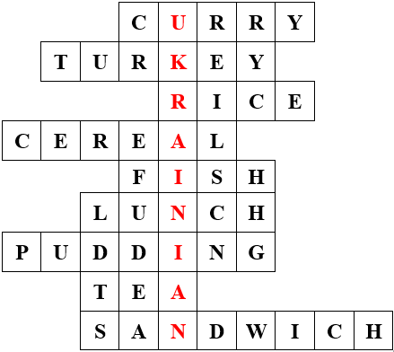

1. Molly’s favourite dish
2. People eat it for dinner at Christmas.
3. The Chinese often eat it.
4. 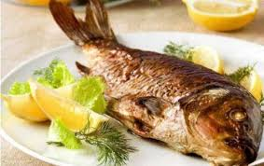British children like to eat it with milk in the morning.
5. ( …. and chips )
6. British people have it between twelve and two pm.
7. 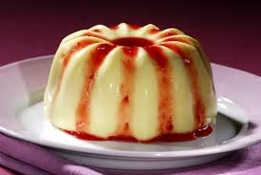
8. British people like to drink it .
9. A lot of people have it in their lunchboxes.

**T:** Thank you. So, what’s the hidden word?

**Ps:** Ukrainian.

**Homework.**

**T:** You are right. At the next morning show we will speak about Ukrainian national dishes and now open your day-books and write down your hometask – read and translate the task about Ukrainian cuisine. And if you want to get a high mark you are to prepare the information about your favourite Ukrainian dish. Your mark will depend on your creativity. You can draw the picture or write the recipe of your favourite dish.

**III. Summing-up**

1. **Reflection**

**T:** Today you’ve learned about traditional British food and British eating habits. Look at your desks. Everyone has got three candies – red, yellow and green one. If you took part in different activities and understood everything, put a green candy in the bowl. If you only helped sometimes and didn’t understand everything, put a yellow candy in the bowl. If you didn’t understand and didn’t remember anything, put a red one.

**2. Evaluation**

**T:** Thank you for your work. I can say that you really worked well and have shown that you are smart students. I’m satisfied with your work. Some of you worked very well today, but some have to be more attentive and more active. But most of all I’m pleased with the work of…

….you worked well too but made some mistakes. You get…

The rest get “Thank you” today. Try to be active and master your English.

Thanks for watching. Good-bye.