**9 клас**

**Тема: Ким я мрію бути**

**Мета:**

* повторити лексичні одиниці теми та активізувати їх вживання в усному мовленні;
* формувати навички вживання нових лексичних одиниць;
* розвивати навички монологічного та діалогічного мовлення, читання, аудіювання;
* розвивати мовну здогадку, логічне мислення, пам’ять та увагу;
* виховувати зацікавленість у вивченні англійської мови, сприяти усвідомленому відношенню до вибору професії.

**Обладнання:** ноутбук, картки з завданнями.

**Хід уроку**

**І. Підготовка до сприйняття іншомовного мовлення.**

**1. Привітання.**

Good morning, children! I am glad to see you!

How are you today?

**2. Повідомлення теми та мети уроку.**

Please, look at the screen and listen to the song. (учні слухають пісню)

What is it about?

Today we are going to speak about your plans for future and your future profession. The topic of our lesson is “Choosing a profession”

At the lesson you’ll learn new words, read the text, do exercises, listen to the poem and speak English.

**3. Уведення в іншомовну атмосферу**

1) На дошці записані прислів’я. Учні мають поєднати частини прислів’я і назвати його укріїнський еквівалент.

Many hands make …. a light work.

The work shows …. the workman.

Well began …. is half done.

Jack of all trades …. is master of none.

2) How many letters are there in English ABCs? – 26.

Let’s revise some popular professions. Name the profession for A, B, C,….(Учні називають прфесії на літери англійського алфавіту)

**ІІ. Основна частина уроку.**

1. Слайд 2. Фонетична зарядка.

There are a lot of professions. This or that profession means that a person does some specific work. And very often professions are derived from other word with the same root.

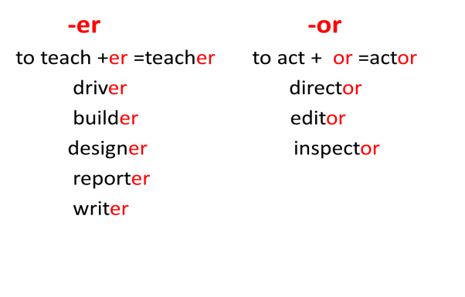

1. Розвиток навичок говоріння.

Speak on the following questions

1. Who helps you choosing your future profession? (Nobody, my parents, my friends)
2. What is, in your opinion, the most important thing in your future profession? (good salary, much contact with people, an ideal combination of a job and a hobby)
3. What skills are the most important for your future profession? (computer skills, observation skills, knowledge of foreign languages)
4. Have you already choosen your future profession?
5. Слайд 3,4,5. Введення нових лексичних одиниць.

Now you will learn some new words. Look at the pictures.

Слайд 6. Complete the sentences

1. Слайд 7. Relaxation

Look at the screen and try to guess “What’s this?”

Слайд 8. A bee. “Busy as a bee”

1. Розвиток навичок читання.
2. Pre- Reading Activity

Слайд 9. New words

salary and benefits - платня і користь

promoted - просувати по службі

retire - вихід на пенсію

enjoying his hobbies - насолоджуватися хоббі

allow to live - дозволяє жити

successful -успішний

transferred – переведений (на іншу посаду)

representatives - представники

poorly paid – мало оплачуваний

1. Reading. The text “ John Rushton is a businessman”

John Rushton is a businessman. He is 50 years old and he has been working for the same company for 27 years.

He thinks that he has a very successful career.He started working as a poorly paid clerk and was one of those nine-to-five white-collar office workers who spend all day with a pencil in one hand and a telephone in another.

He hated it and asked to be transferred to sales where he became one of the company’s sales representatives.

John travelled all over the country selling the company products and eventually became the most successful salesperson on the stuff.

In ten years he was promoted to manager of the sales department. He has got a good salary and benefits.

He might retire in another ten years and then his pension will allow him to live comfortably in his country house enjoying his hobbies that he has no time for now while he still works.

1. Post- Reading Activity

Слайд 10. Read the statements and decide if they are true or false.

1.John didn’t get much money when he started his career.

2.John worked till late evening.

3.He enjoyed his work as an office-worker.

4.John had no opportunity to travel.

5.Being a manager John earned good money.

6.Now John is retiring and has enough time for his hobby.

7.John’s pension will allow him to live comfortably.

6. Розвиток навичок аудіювання.

1)Listen to the poem “I Want To BE...”

Some people often say to me:

“Have you decided what you want to be?”

I usually answer, ” I don’t know”,

But it isn’t really so.

I want to win an Olympic race,

I want to see the Earth from space,

I want to travel to Katmandu,

I want to be rich and famous, too.

I want to be on Hollywood’s screen,

I want to invent a new machine,

I want to be very clever and wise,

I want to win the Nobel prize,

But most of all, I want to be

Healthy, and strong, and nice!

2) After listening students have to fill in the gaps and read the poem, answer teacher’s questions.

What is this poem about?- This poem is about our interests\ hobbies\ dreams\ jobs

What did you understand from the poem?

7.Розвиток навичок говоріння.

Now tell me ,please, what profession would you like to choose . Слайд 11.

**ІІІ. Заключна частина уроку.**

1. Домашнє завдання. Слайд 12.

Write an essay “my plans for future”

1. Підведення підсумків уроку

Was the lesson interesting?

What task did you like the most?

What new words did you learn?

Слайд 13.