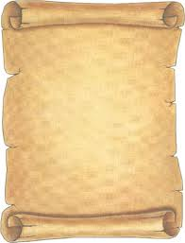

**Personal informational sheet**

**Name:*Halyna***

**Surname:*Shumska***

**Permanent address:*97,Bilasovytsia,Volovets***

***district,Zakarpatska oblast,Ukraine***

**Nationality:*Ukrainian***

**Date of birth:*February,24,1977***

**Place of birth:*Bilasovytsia,Ukraine***

**Occupation:*a teacher of English language and***

***literature***

**Place of employment:*Tyshiv school***

**General teaching experience:*16 years***

**Qualification:*a high category***