***In a Small Town***

***Text 1***

Toscanini was a great musician. He lived in America. One day he came to a very little town. He was walking along the street when he saw a piece of paper in one of the windows. He read:

MRS.SMITH.MUSIC LESSONS.

TWO DOLLARS A LESSON.

Then Toscanini heard the music. Somebody was playing Tchaikovsky.

“Mrs. Smith is playing,” he thought, “she isn’t a very good musician. She doesn’t play Tchaikovsky well. I must show her how to play it.”

He went up to the door of the house and rang. The music stopped and soon a woman opened the door.

“Are you Mrs. Smith?” asked Toscanini. “My name is Toscanini and I want to show you how to play Tchaikovsky.”

Mrs. Smith was very glad to meet the great musician. She asked him to come in. Toscanini played Tchaikovsky for her and went away.

A year later Toscanini visited the same town again. When he went up to the house where he had played Tchaikovsky the year before he again saw a piece of paper. Now it read.

MRS.SMITH. (TOSCANINI’S PUPIL)

MUSIC LESSONS.

FOUR DOLLARS A LESSON.

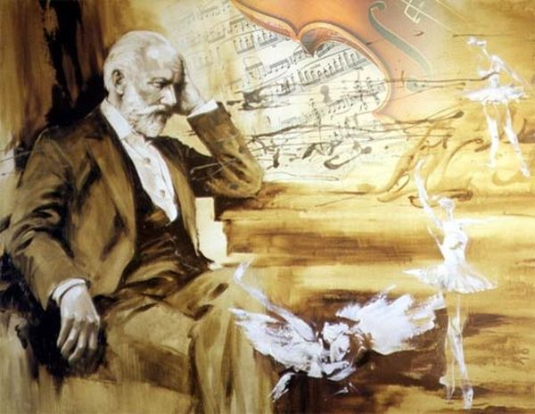

***Tasks for the text 1***

**1. Put “+” if the sentence is right and “-“if it is wrong.**

1.Toscanini came to a very little town.

2.He liked how Mrs. Smith was playing.

3.He wanted to play the piano for her.

4.Tchaikovsky visited Mrs. Smith one day.

5.Mrs. Smith was a teacher of music.

**2. Write the sentences in the right order.**

Mrs. Smith was very glad to meet the great musician.

He lived in America.

The music stopped and soon a woman opened the door.

The music stopped and soon a woman opened the door.

“Mrs. Smith is playing,” he thought, “she isn’t a very good musician.

**3. Answer the questions.**

1.Where did Toscanini live?

2.Toscanini was a great musician, wasn’t he?

3.Did he want to show Mrs. Smith how to play?

4.What did he see in one of the window?

5.Did he think that Mrs. Smith was playing well?

**4. Write down the ending of the sentence.**

1.One day he came…

2.I must show her…

3.The music stopped and soon…

4.Toscanini played Tchaikovsky for …

5.Four dollars…

**5. Make up 5 questions to the text.**

***Shmily***

***Text 2***

My grandparents were married for over half a century, and played their own special game from the time they had met each other. The goal of their game was to write the word “Shmily” in a surprise place for the other to find. They took turns leaving “Smily” around the house, and as soon as one of them discovered it, it was their turn to hide it once more.

They dragged “Smily” with their fingers through the sugar and flour containers to wait whoever was preparing the next meal. They smeared it in the dew on the windows overlooking the patio where my grandma always fed us warm, homemade pudding with blue food coloring. “Shmily” was written in the steam left on the mirror after a hot shower, where it would reappear bath after bath. At one point, my grandmother even unrolled an entire roll of toilet paper to leave Shmily on the very last sheet.

There was no end to the places “Shmily” would pop up. Little notes with “Shmily” scribbled hurriedly were found on dashboards and car seats, or taped to steering wheels. The notes were stuffed inside shoes and left under pillows. “Shmily” was written in the dust upon the mantel and traced in the ashes of the fireplace. This mysterious word was as much a part of my grandparents’ house as the furniture.

It took me a long time before I was able to fully appreciate my grandparents’ game. Skepticism has kept me from believing in true love- one that is pure and enduring. However, I never doubted my grandparents’ relationship. They had love down pat. It was more than their flirtatious little games; it was way of life. Their relationship was based on a devotion and passionate affection which not everyone is lucky enough to experience.

Grandma and grandpa held hands ever chance they could. They stole kisses as they bumped into each other in their tiny kitchen. They finished each other’s sentences and shared the daily crossword puzzle and word jumble. My grandma whispered to me about how cute my grandpa was, how handsome an old man he had grown to be. She claimed that she really knew “how to pick ‘em”. Before every meal they bowed heads and gave thanks, marveling at their blessing: a wonderful family, good fortune, and each other.But there was a dark cloud in my grandparents’ life: my grandmother had breast cancer. The disease had first appeared ten years earlier. As always, Grandpa was with her every step of the way. He comforted her in their yellow room, painted that color so she could always be surrounded by sunshine, even when she was too sick to go outside.Now the cancer was once again attacking her body. With the help of a cane and my grandfather’s steady hand, they still went to church every morning. But my grandmother grew steadily weaker until, finally, she could not leave the house anymore. For a while, Grandpa would go to church alone, praying to God to watch over his wife. Then one day, what we all dreaded finally happened. Grandma was gone. “Shmily. It was scrawled in yellow on the pink ribbons of my grandmother’s funeral bouquet. As the crowd thinned and the last mourners turned to leave, my aunts, uncles, cousins, and other family members came forward and gathered around Grandma one last time. Grandpa stepped up to my grandmother’s casket and, taking a shaky breath, he began to sing to her. Though his tears and grief, the song came, a deep and throaty lullaby.

Shaking with my own sorrow, I will never forget that moment. For I knew then that, although I couldn’t begin to fathom the depth of their love, I had been privileged to witness its unmatched beauty. S-H-M-I-L-Y: See How Much I Love You.Thank you , Grandpa and Grandma, for letting me see.Laura Jeanne Alien

**Tasks for the text 2**

**1. Answer the questions.**

1.What was the goal of the game have been played by the grandparents?

2.Where could this mysterious word be found?

3.What disease had grandmother?

4.What song did grandfather sing to grandma when she had died?

5.What color did grandpa paint their room when grandma was sick and why?

**2 . Find sentences which prove that grandparents had true love.**

**3. Write the sentences in the right order.**

The grandpa sang a lullaby to grandma on her grave when she died.

The author of this story was proud to witness the beauty of true love.

The grandparents were married about fifty years.

As usually grandpa helped her every step of the way.

I never doubted my grandparents relations.

**4. Make up 5 questions to the text.**

***Forks and fingers***

***Text 3***

In 1608 an Englishman whose name was Thomas Coryate visited Italy. He liked the country and noted down every interesting thing he found. But there was one thing which he found more interesting than the others. In his diary Thomas wrote, “When the Italians eat meat, they use small forks. They don’t eat with hands because, as they say , do not always have clean hands”.

Before leaving for England, Thomas Coryate bought a few forks.

At home Thomas gave a dinner party to show the invention to his friends. When the servant brought the steak, he took out a fork and began to eat like they did in Italy.

Everybody looked at him in surprise. When he told his friends what it was, they all wanted to take a good look at the strange thing. All his friends said that the Italians were very strange people because the fork was very inconvenient.

Thomas Coryate tried to prove the opposite. He said it was not nice to eat with one’s fingers because they were not always clean.

Everybody got angry at that . Did Mr. Coryate think that people inEngland always had dirty hands? And weren’t the ten fingers they had enough for them?

Thomas Coryate wanted to show that it was very easy to use the fork. But the first piece of meat he took with the fork fell to the floor. His friends began to laugh and he had to take the fork away.

Only fifty years later people in England began to use forks.

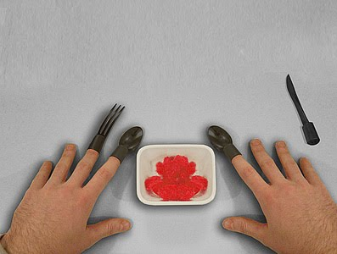

**Tasks for the text 3**

**1. Translate the following sentences into Ukrainian:**

1.In 1608 an Englishman whose name was Thomas Coryate visited Italy.

2.But there was one thing which he found more interesting than the others.

3.He said it was not nice to eat with one’s fingers because they were not always clean.

4.But the first piece of meat he took with the fork fell to the floor.

**2. Answer the questions:**

1.Why did the Italians eat with the forks?

2.What did he give at home to show the invention of the Italians?

3.Why did his friends begin to laugh?

4.When did people in England begin to use forks?

**3. Correct according to the contents of the text :**

They eat with the hands because, as they say, do not always have clean hands.

Everybody got happy at that.

Only seventy years later people in England began to use forks.

When the servant brought the steak, he took out a knife and began to eat like they did in Italy.

**4. Put 5 questions to the text.**

***London***

***Text 4***

London is the capital of Great Britain. London is a very old town. London is two thousand years old. Many years ago London was a small town on the Thames. There were a lot of villages round it. After many years London and three hundred villages grew into a very large city. Some of the names of those villages are the names of the streets in modern London-Kensington, Westminster.

Now London is a beautiful city with large squares and parks. The city of London is the business centre. East End includes the poor districts. West of London is the West End where rich people live.

Trafalgar Square is in the centre of the West End of London. In the centre of Trafalgar Square there is the column made of granite. On the top of the column there is a 17-feet-tall statue of Admiral Nelson who defeated the French at the Battle of Trafalgar in 1809. The total high of the monument is 184 feet (44 meters).On the pedestal is a bronze relief cast from a captured French cannon, representing Nelson’s victory.

On the North side of Trafalgar Square is the National Gallery.

The National Gallery has one of the finest collections of pictures in the world.

Trafalgar Square is one of the busiest place in London, where people go to and from the work, it is hard to cross the street.



**Tasks for the text 4**

**1. Answer the questions**

1.What is the capital of Great Britain ?

2.How many years is London?

3.What includes the poor districts?

4.Where do rich people live?

5.Where is the Admiral Nelson column?

**2. Complete the sentences:**

1.On the top of the column …

2.London is two…

3.On the north side…

4.The total high…

5.There were…

**3. Choose”true” or “false”**

1.London is a new town.

2.London is on the Thames.

3.The West End of London is a place where rich people live.

4.In London there aren’t a lot of squares and parks.